

**PURCHASE FUNNEL PROJECT**

**Part 1**

To find insights on a website, every single activity of the customer on the website needs to be examined. In this way, a marketing funnel will show the customer journey from visiting the website and viewing a product or listing, to initiating the purchase and the moment of purchase. By analyzing each stage, it is aimed to provide an advantage for senior management or business partners to make business decisions.

To recap these key metrics:

1. **Awareness** : Visiting the website by user.
2. **Interest** : The user starts researching the product to gather more information about its features in product page.
3. **Consideration** : The prospect compares the product with other products searches from the listing page.
4. **Intent** : When the potential customer decides to buy the product, but there is a final stage left to make a commitment.
5. **Purchase** : Placing an order for the product(s).

Next step, should be performed various calculations for the key metrics that have determined and I will reveal the behavior of the customer on the website finally.

1. **Page Views to Awareness**

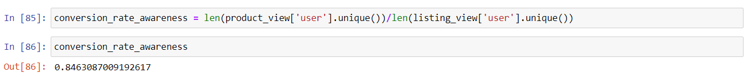

This value indicates that around **84.63%** of the visitors to the website during the awareness phase performed a desired action. I thought that this result from the number of product views will be revealed by the ratio of the number of list views or search list views which are the next stage. This high conversion rate shows that this first stage on the website effectively engages visitors and converts them into leads or customers.

1. **Interest (Consideration) Conversion Rate**

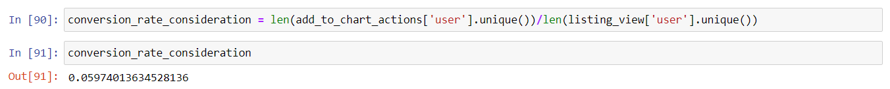

This value indicates that approximately **5.97%** of the potential customers who evaluated the product prices successfully converted. Product evaluations and insights are only understood through the add to chart. The ratio of the number of products added to the cart to the number of list views will give us this change. Measuring all these activities according to distinct user will be an accurate indicator. This means that a small percentage of all users who research and evaluate the product ultimately decide to buy.

1. **Purchase Conversion Rate**



Purchase Conversion Rate **72.94%** is a strong indicator of an effective checkout process. I thought that the conversion rate of product(s) added to cart to order will be found by the ratio of the number of orders to add to cart. This value, which shows the order conversion rate of the products added to the chart, can be interpreted that the payment system is user friendly, fast, and secure.

**Additional Data/Information**

1. The **price** data is a target data, but it can be made based on the price distribution and the steps of displaying, carting and ordering the products.
2. The **user information** will contribute a lot to the strategy. Especially **age** and **location** will be important criteria for product viewing. **Occupation** can be one of the most important types of information. However, I thought that it would not be easy for the user to share the occupation information, so I mentioned it as an alternative.
3. **The Length of stay** on the product page, listing page or checkout page can reveal insights into where or on which products users spend the most time.

**Part 2**

1. Number of clients by day that:

- only viewed products in their first session;

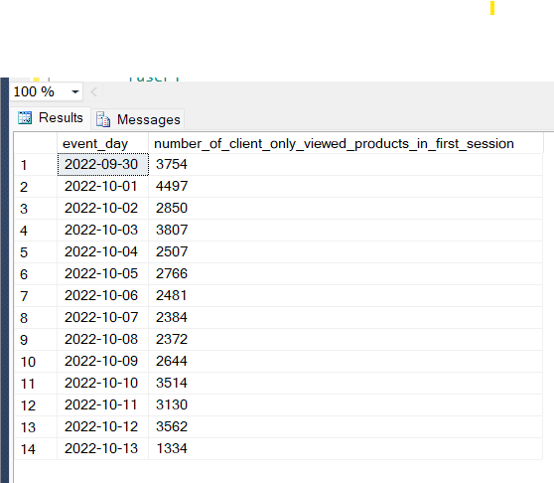

- added only one product to the basket;

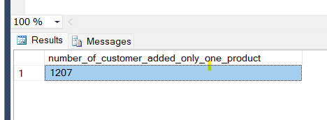

- placed an order within two days’ time after the first session.

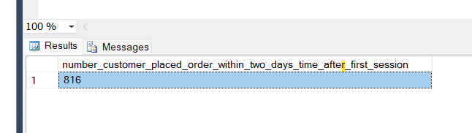

2. Abnormal (to our view) user behavior.

In my current role, one of the tasks I am responsible for is task automation. It automates the repetitive work of stakeholders and business partners, making it easy to create reports or extract and manipulate data. But I thought this could be dangerous for a website. For example, in a project I did, it was logging in to a website by opening a browser and extracting data from that website. A competitor or other users can log in to the website and perform various actions. I thought this activity would be effective in investigating abnormal behavior in the given task.

* + More than one session in short time
  + Only one added product/ huge number products
  + High events amount

The combination of these factors can point to various types of anomalous behavior.

What interests me about this dataset is the large number of products for a small number of events. There are two reasons for them : the first one the user has definitely perfect knowledge about the products and might perfectly know what should buy or the second one that it is a robot /automation 😊

For example;

